Keeping your information safe.
Easy read booklet
Torrington Health Centre
New Road, Torrington, EX38 8EL
Tel: 01805 622247
Website: https://torringtonhc.co.uk/

What is a privacy notice?  The doctor’s surgery uses your information like:  Your name  Address  It has notes that doctors and nurses have written when you come in for appointments.  This helps them care for you well.  A privacy notice tells you how your information is used.  It helps to protect your information. | 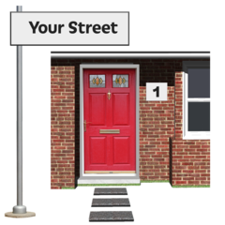
Why do we need a privacy notice?

Your doctor’s surgery have to follow the law.

This means that you have the right to know how your information is used.

The doctor’s surgery make sure it is easy to understand.

This helps people know what happens to their information.

What is the GDPR?  It is a new document that tells your doctor’s surgery what they need to do.  It makes sure your doctor, nurses and other staff follow the rules.  This will help keep your information confidential and safe.  Confidential means it is safe and only people who need to know will see your information.  This document is called the General Data Protection Regulation. | 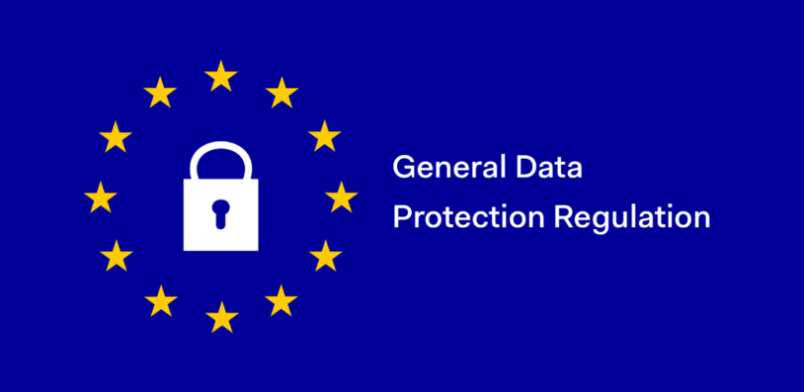
How do you know about our privacy notice?  You will see posters in the waiting room.  You will see leaflets that show how your information is used.  There will be information on our website. | 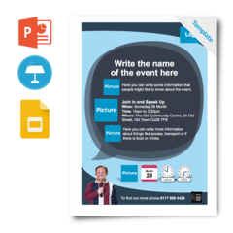

What information do we have about you?  The doctor’s surgery keep information about you. This is to keep you healthy.  They will keep:  Your name  Address  Telephone number  Information about your family or carer’s  The appointments you have had with the doctors  Treatments you have had  Test results  Medication you are on  This helps the doctors and nurses to keep you healthy and well. | 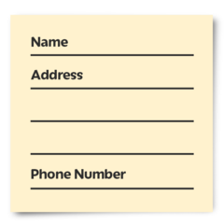  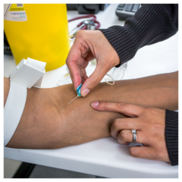

How do we use your information about you?

Your doctor’s surgery uses your information to make sure you get the best care.

Sometimes, they might need to share this information with the hospital.

This is so the doctors know who you are and what healthcare you need.

Your doctor’s surgery might be asked to help with research to make healthcare better.

This might mean talking to patients

Making the answers they get into charts

Then write a report

If they do, they will ask you if it is OK to share your information.

They might ask your family.

How do we keep your health information private?

We keep it safe.

We follow the law.

We only tell people who need to know. This could be:

Your family

Your support workers

Other healthcare professionals

We only tell people who you have said is OK to know.

We follow the rules in the GDPR.

What if I have a long-term health problem?

We share your information with other healthcare people.

They can then help you to get the right care for you.

You can say Yes or No to sharing your information.  You can say yes if you want to share your information.  You can say no if you do not want your information to be shared.  If you are under 16 your parents or adults who support you will say yes or no. | 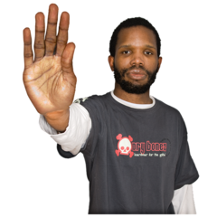
How do I see my health information?  You can ask for your healthcare information at your doctor’s practice.  Do a ‘Subject Access Request’ and give it to your doctor.  This means you can see what is written about you.  If you are under 16 your parents or adults who support you will do the form. | 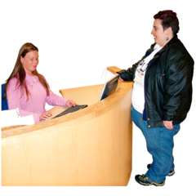
What do I do if I have questions?

If you have questions you can:

- Email the GP practice and ask them

- Write to the GP practice

- Ask to talk to the manager of the doctors

What to do if you are not happy about how your information is looked after.

We want you to be happy.

If you are not happy, you can complain.

If you want to complain, talk to the manager of the doctors.

If you want to talk to the authority you can contact:

Information Commissioner’s Office
Wycliffe house
Water Lane
Wilmslow
Cheshire
SK9 5AF

Tel: 0303 123 1113 or 01625 545745
www.informationcommissioner.gov.uk
Changes to our privacy policy  We look at our privacy policy every year.  If we need to, we make changes to make sure we keep you happy. | 